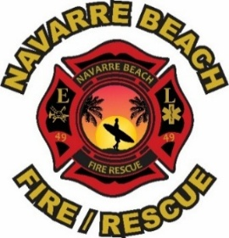

1413 Utility Drive
Navarre, FL 32566
Office: 850-939-2448
Fire Chief Danny Fureigh

Posted: January 5, 2025

Navarre Beach Fire Rescue District
Community Workshop Notice on Reclassification

Fire Chief Danny Fureigh will hold a community workshop to discuss a resolution applying the District’s commercial property fire assessment rates to transient public lodging establishments (“TPLE”) or short-term rentals.

Date & Time:
Thursday, January 15, 2026 at 4:00 pm
Location:
NBFR Lifeguard House
8640 Blue Heron Ct., Navarre, FL 32566

Should any interested party seek to appeal any decision made by the Navarre Beach Fire Rescue District with respect to any matter considered at this meeting, they will need to ensure that a verbatim record of the proceedings is made, which record includes the testimony and evidence upon which the appeal is to be based. In accordance with the Americans with Disabilities Act, persons needing accommodations should contact our office at (850) 939-2448 within a reasonable time prior to the meeting.

